Amazon Sales BI & Predictive Analytics Dashboard
1. Project Overview
This project is a high-performance Business Intelligence (BI) application built to analyze a decade of Amazon India sales data. The system transforms raw, messy transactional data into actionable insights using a modern tech stack. It covers six major business areas, ranging from basic revenue tracking to advanced machine learning-based sales forecasting and churn prediction.
2. Tech Stack
- Frontend & UI: Streamlit (Python-based Web Framework)
- Data Processing: Pandas, NumPy
- Database: PostgreSQL (Relational Database Management System)
- Visualization: Plotly Express (Interactive Charts)
- Statistical Modeling: NumPy Polyfit (Linear Regression)
3. Data Architecture & Pipeline
The project follows a standard Data Engineering lifecycle:
- Extraction: SQL queries fetch real-time data from the public.maintable in PostgreSQL.
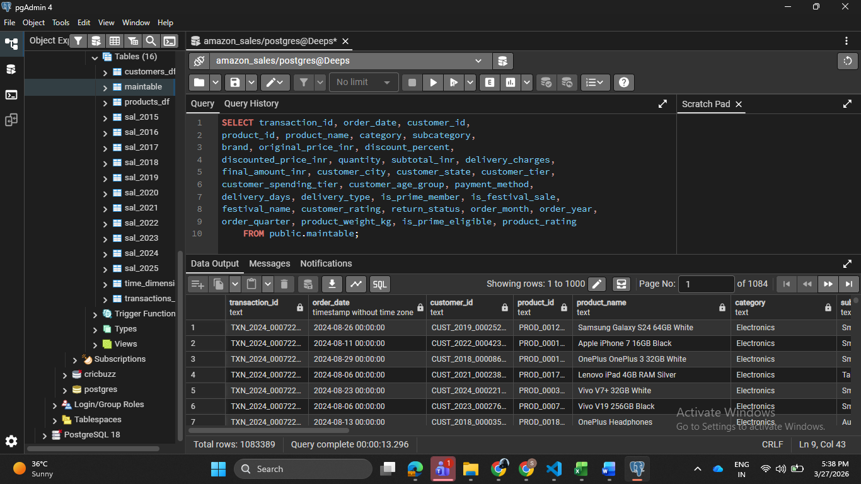

- Transformation (Cleaning):
  - Handling currency formats (removing commas/symbols). Standardizing these involves removing non-numeric characters using functions like .str.replace(',', '').
  - Datasets frequently have "holes" where information like customer ratings or delivery charges was not recorded.
  - System glitches can result in the same transaction being recorded multiple times.
  - Converting date strings to datetime objects for time-series analysis.
  - Coercing numeric columns to handle "dirty" text data.
  - Imputing missing values in delivery charges and ratings.
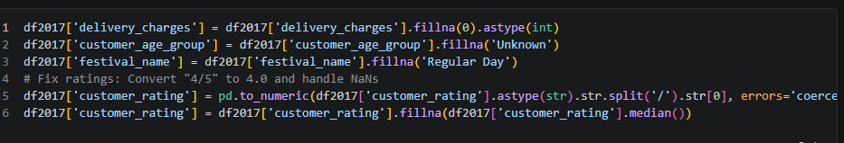
- Loading: Data is loaded into Pandas DataFrames for on-the-fly computation within the Streamlit app.
4. Key Modules & Features
Module 1: Executive Dashboards
The Executive Command Center acts as a high-level strategic hub, offering a comprehensive "bird’s-eye view" of organizational health. It transforms raw operational data into a real-time oversight tool, enabling leadership to monitor performance and respond to critical business shifts instantly.
Core Performance Metrics (KPIs)
The dashboard tracks four vital pillars of business health:
- Financial Strength: Total Revenue and Average Order Value.
- Operational Speed: Average Delivery Times and Order Volume.
- Customer Sentiment: CSAT (Customer Satisfaction) Scores.
- Quality Control: Return Rates and Product Defect Ratios.

Key Strategic Functionalities
- Automated Threshold Monitoring: The system utilizes intelligent alerting to flag anomalies immediately. Visual cues, such as Red "Critical" Banners for logistics bottlenecks or Yellow "Warning" Banners for spikes in returns, ensure that urgent issues are never overlooked.
- Strategic Decision Support: Beyond just showing data, the dashboard provides actionable insights. By calculating real-time order velocity, it assists management in making data-driven decisions regarding warehouse staffing levels and resource allocation during peak demand.
- Efficiency & Latency Mapping: Through the "Global Performance Pulse" scatter plot, the center visualizes the complex relationship between sales volume and fulfillment speed. This helps identify "efficiency hotspots" where high revenue might be causing strain on delivery infrastructure.
- Data Portability & Governance: To support deep-dive analysis and offline reporting, the module includes an integrated Export Engine. Executives can generate and download comprehensive summaries in CSV format, ensuring data accessibility for stakeholder presentations and long-term planning.

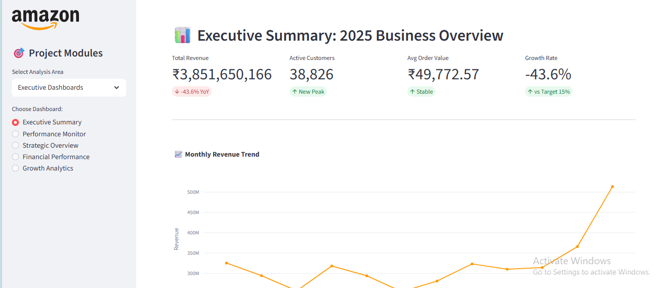
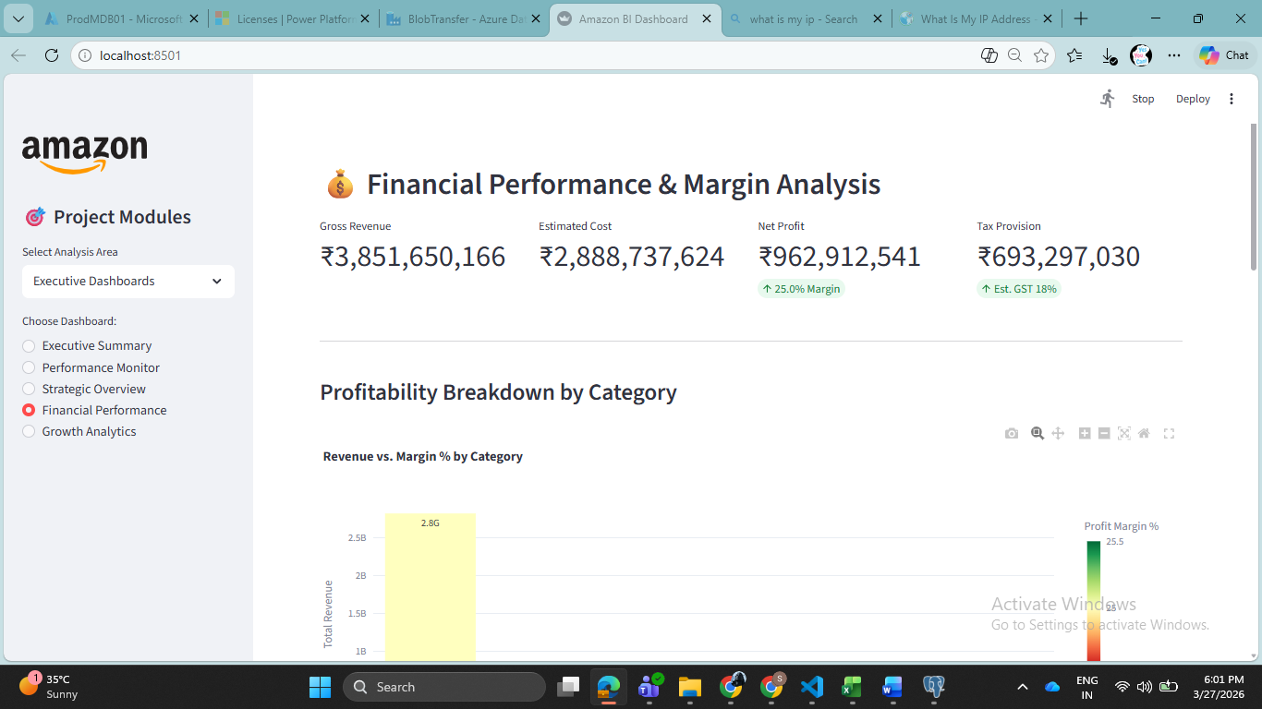
Module 2: Revenue & Customer Analytics
The Revenue Analytics module transitions the dashboard from high-level oversight to granular financial intelligence. This section is designed to help stakeholders identify exactly where money is being made, when demand peaks, and how pricing strategies impact the bottom line.
1. Revenue Trend & Forecasting
This sub-module analyzes the "velocity" of the business. By aggregating data into monthly, quarterly, and yearly buckets, it identifies long-term growth trajectories.
- Time-Series Analysis: Visualizes historical revenue patterns to identify cyclical growth.
- Interactive Selection: Users can toggle between time grains (e.g., viewing a 3-year trend vs. a 6-month deep dive).
- Growth Rate Tracking: Calculates Month-on-Month (MoM) and Year-on-Year (YoY) percentages to flag decelerating or accelerating segments.
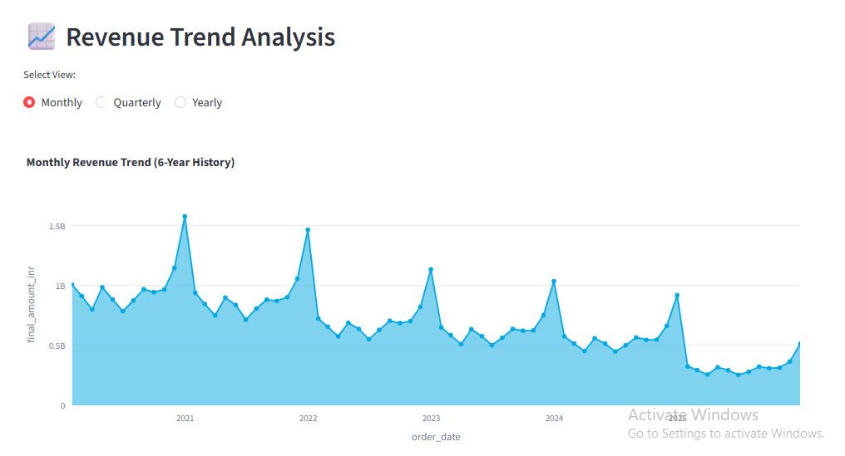
2. Category Performance & Market Share
Not all products contribute equally to the margin. This dashboard breaks down the "Revenue Mix."
- Contribution Analysis: Uses Treemaps and Sunburst charts to show which categories (e.g., Electronics vs. Apparel) dominate total sales.
- Drill-Down Capabilities: Allows users to click on a category to see the performance of specific subcategories.
- Market Share Dynamics: Tracks how category "dominance" shifts over time, identifying emerging trends before they plateau.
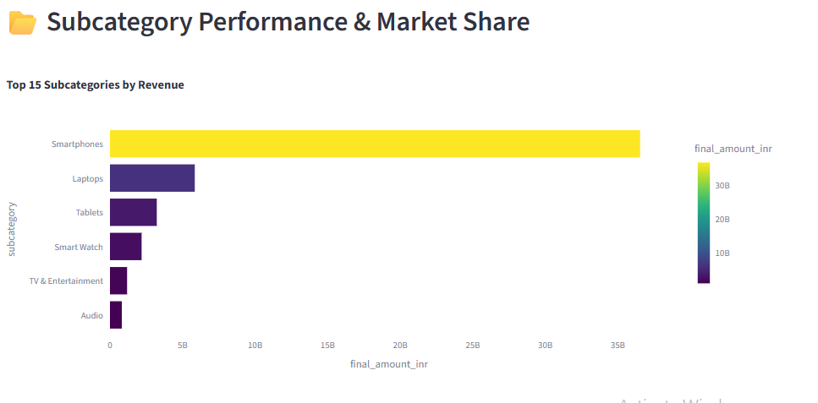
3. Geographic Revenue & Market Penetration (Question 8)
This module maps the physical footprint of Amazon India’s sales, focusing on regional expansion.
- Interactive Geospatial Maps: Uses choropleth maps to visualize state-wise and city-wise revenue density.
- Tier-Wise Analysis: Segments performance by City Tiers (Tier 1, 2, and 3) to identify untapped market penetration opportunities in rural vs. urban areas.
- Regional Growth Patterns: Pinpoints specific geographies where marketing spend is yielding the highest Return on Investment (ROI).
4. Festival & Seasonal Sales Analytics (Question 9)
In the Indian context, festival seasons (like Diwali or Great Indian Sale) represent a massive portion of annual revenue.
- Campaign Effectiveness: Compares "Festival" periods against "Non-Festival" baselines to calculate the true "lift" generated by sales events.
- Promotional Impact: Analyzes how specific holiday banners and limited-time offers drive volume.
- Optimization Insights: Provides data on whether the increased volume during sales is high enough to offset the lower margins caused by heavy discounting.

5. Price Optimization & Elasticity (Question 10)
This section acts as a laboratory for pricing strategy. It answers the question: "If we lower the price, do we sell enough extra units to make more profit?"
- Price Elasticity Modeling: Analyzes the relationship between price changes and quantity sold to find the "Sweet Spot."
- Discount Effectiveness: Tracks the correlation between discount percentages and total revenue to prevent "profit bleeding."
- Competitive Positioning: Monitors average unit prices across different subcategories to ensure the brand remains competitive without entering a "price war."
Module 3: Customer Analytics (Behavioral Intelligence)
The Customer Analytics module shifts the focus from "What was sold" to "Who is buying." This section utilizes advanced behavioral modeling to categorize the Amazon India customer base, allowing for hyper-targeted marketing and retention strategies.
1. RFM Segmentation & Behavioral Profiles
This dashboard implements the Recency, Frequency, and Monetary (RFM) framework to rank customers.
- RFM Scoring: Automatically categorizes users into segments such as "Champions" (bought recently, often, and spent much), "At Risk" (haven't bought in a long time), and "New Customers."
- Targeted Recommendations: Provides specific marketing actions for each segment (e.g., "Send a VIP discount to Champions" or "Send a 'We Miss You' email to At Risk users").
- Lifetime Value (LTV) Analysis: Predicts the total revenue a customer will generate over their entire relationship with the platform.
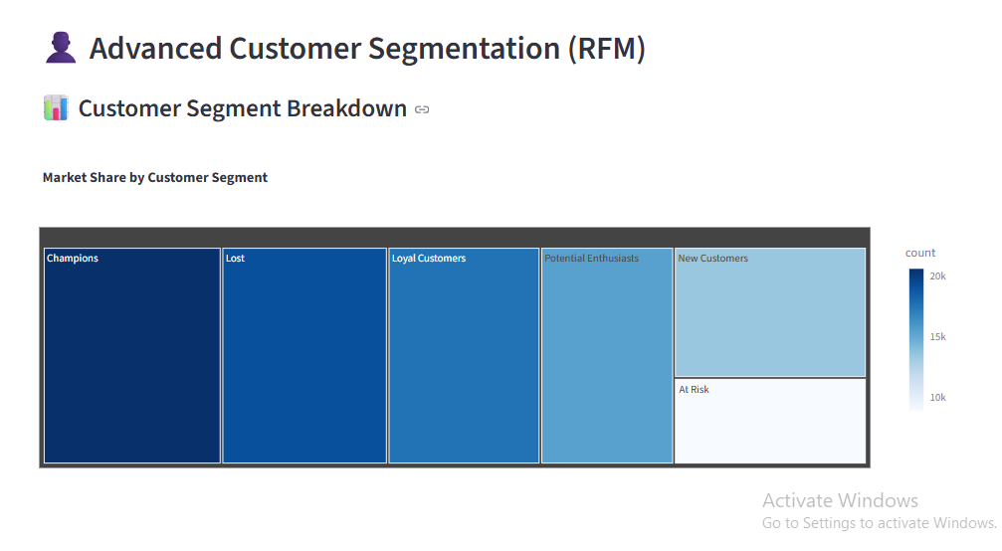
2. Customer Journey & Evolution
This sub-module tracks the "Path to Purchase" and how a casual browser becomes a loyal advocate.
- Acquisition Tracking: Identifies which channels (Search, Social Media, Direct) bring in the most high-value users.
- Category Transitions: Analyzes how customers move between categories (e.g., a user who first buys a "Phone" and later transitions to "Mobile Accessories").
- Loyalty Funnel: Visualizes the conversion rate of first-time buyers into repeat and eventually "Loyal" customers.
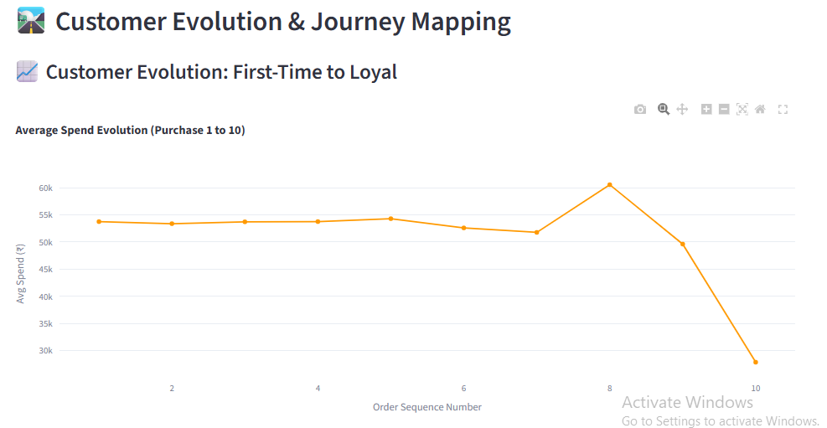
3. Prime Membership Analytics
This dashboard audits the impact of the Amazon Prime ecosystem on total business health.
- Behavioral Comparison: Side-by-side analysis of Prime vs. Non-Prime members regarding Average Order Value (AOV) and purchase frequency.
- Membership Value: Calculates the "Subscription Lift"—the additional revenue generated by a user after they join the Prime program.
- Retention Rates: Monitors how long Prime members stay active compared to standard users, highlighting the program's role as a "loyalty moat."
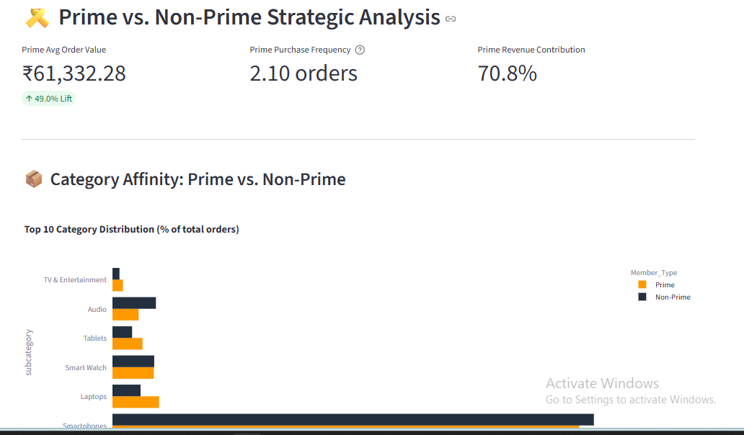

4. Retention, Cohorts & Churn
Focuses on "Leaky Bucket" syndrome—identifying why customers stop shopping and how to keep them.
- Cohort Analysis: Groups customers by their "Join Month" to see how their spending tapers off or grows over time (e.g., "Do customers who joined during the Diwali sale stay active longer?").
- Churn Prediction: Uses statistical triggers to flag users who are likely to stop using the platform based on a drop in login or purchase activity.
- Lifecycle Management: Provides insights into the "Average Customer Lifespan" and the effectiveness of re-engagement strategies.
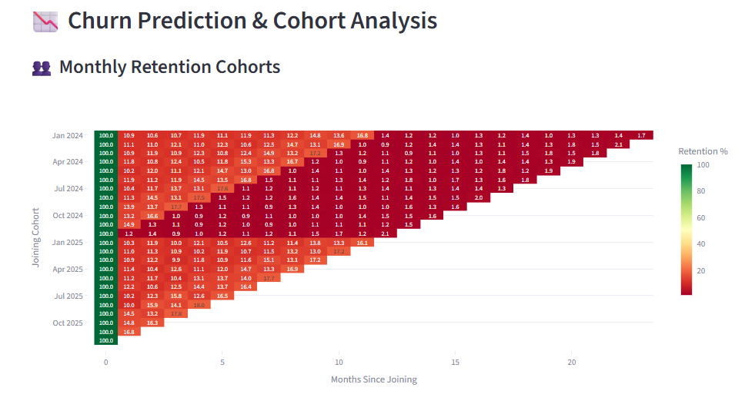
5. Demographics & Spending Patterns
Maps customer identities to their buying habits to uncover demographic opportunities.
- Profile Analysis: Segments the audience by age groups and spending tiers to see which demographics are the most profitable.
- Geographic Behavior: Connects regional demographics to specific product preferences (e.g., "High-end electronics demand in Bangalore vs. Traditional apparel demand in Jaipur").
- Targeted Marketing Opportunities: Identifies "Niche" groups that are under-served but have high spending potential, guiding future inventory and ad spend.
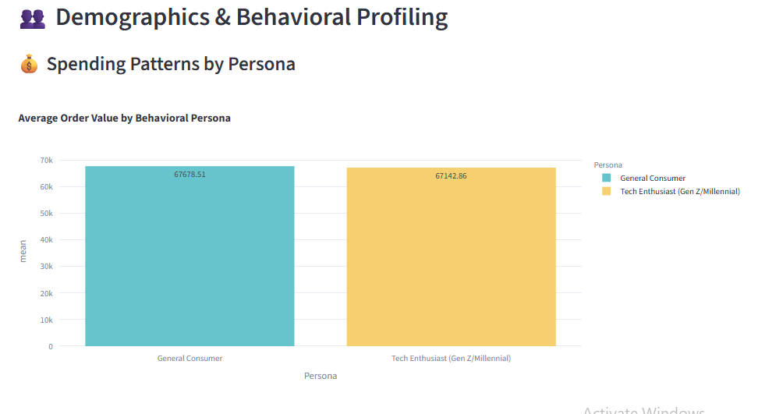
Module 4: Product & Inventory Analytics (Optimization & Performance)
The Product & Inventory Analytics module is designed to bridge the gap between sales and supply chain operations. It focuses on identifying high-performing products, managing stock levels efficiently, and understanding brand positioning within the Amazon India ecosystem.
1. Product Performance & Lifecycle Tracking
This dashboard provides a definitive ranking of the catalog to separate "Stars" from "Laggards."
- Multi-Metric Ranking: Sorts products by a balance of revenue, units sold, average customer ratings, and return rates.
- Category-Wise Deep Dive: Allows managers to see performance leaders within specific niches (e.g., "Top 5 Smartphones" vs. "Top 5 Laptops").
- Lifecycle Analysis: Tracks products from "Launch" to "Maturity," helping teams decide when to liquidate old stock or double down on trending items.
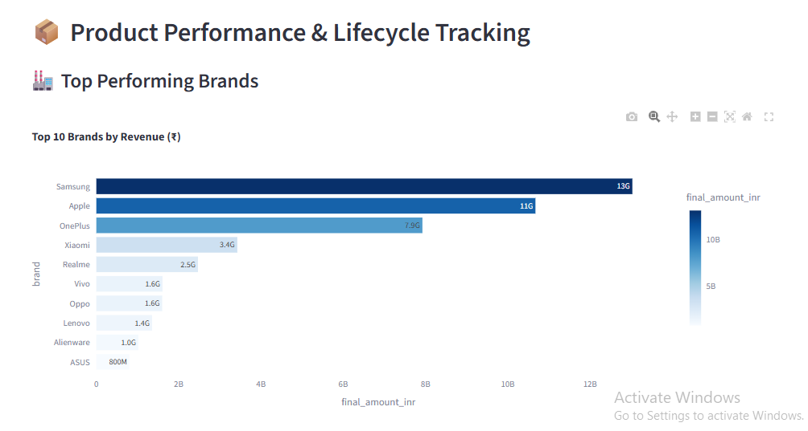
2. Brand Analytics & Competitive Positioning
In a multi-vendor marketplace, understanding brand strength is vital for strategic partnerships and competitive strategy.
- Market Share Evolution: Visualizes how a brand’s slice of the category pie grows or shrinks month-over-month.
- Competitive Benchmarking: Compares internal brands against external competitors on metrics like price-point and customer sentiment.
- Preference Mapping: Identifies which brands are "Consumer Favorites" in specific geographic regions or city tiers.
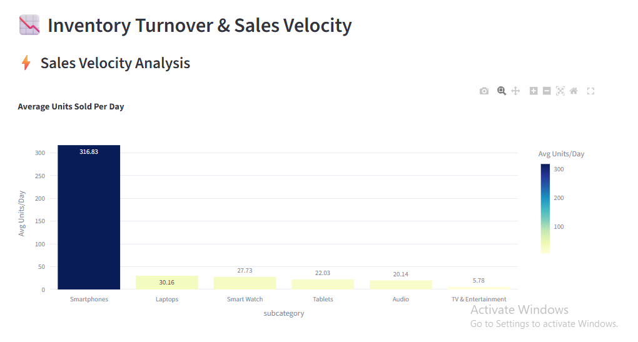
3. Inventory Optimization & Demand Forecasting
This sub-module acts as the "brain" for the warehouse, focusing on reducing carrying costs while preventing lost sales.
- Inventory Turnover Ratio: Measures how many times a product's stock is sold and replaced over a period; high turnover indicates high efficiency.
- Demand Pattern Recognition: Identifies "Slow-Moving" vs. "Fast-Moving" goods to optimize shelf space.
- Predictive Stocking: Uses seasonal trends and historical demand to forecast how much inventory is needed for the upcoming month.
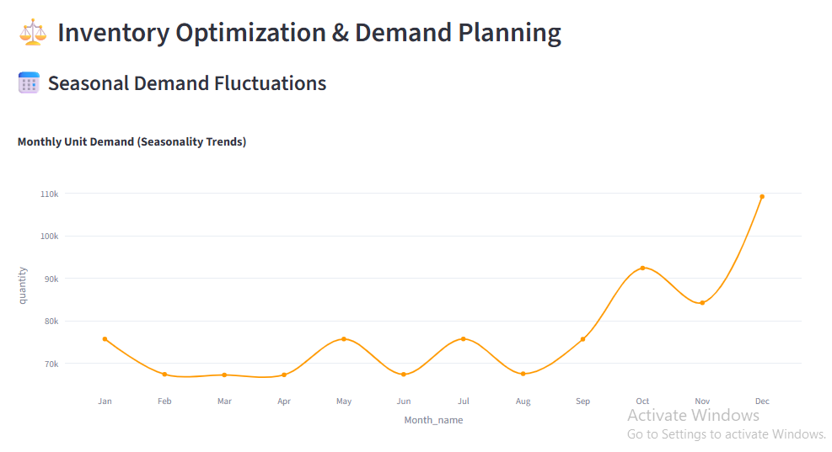
4. Product Rating & Quality Insights
This dashboard translates customer feedback into technical quality improvements.
- Rating Distribution: A histogram view of 1-star vs. 5-star reviews to identify "Polarizing" products.
- Correlation Analysis: Graphs the relationship between high ratings and sales velocity to prove the ROI of quality control.
- Sentiment Extraction: Identifies recurring keywords in reviews (e.g., "Poor Battery" or "Premium Feel") to guide future product development.
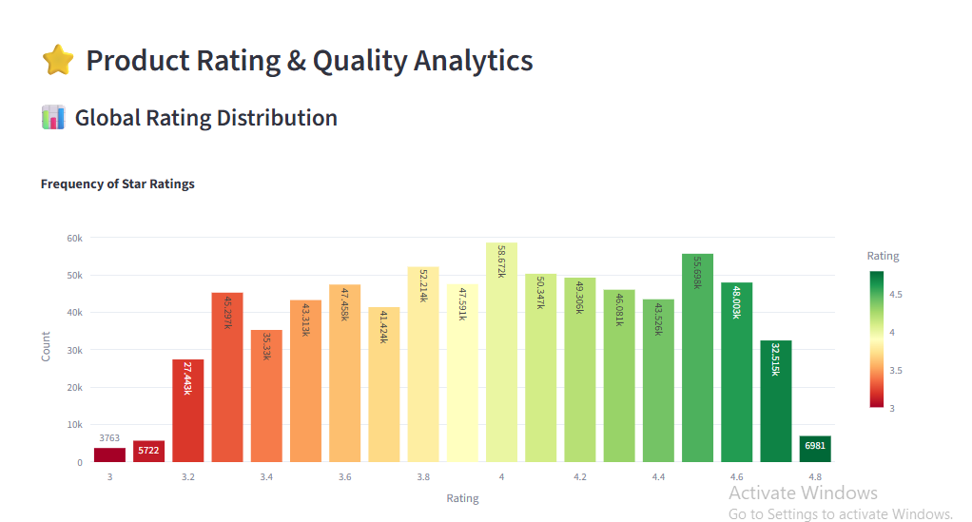

5. New Product Launch & Success Metrics
Launching a product is high-risk; this dashboard provides the data needed to pivot or persevere.
- Launch Velocity Tracking: Monitors sales and "Page Views" during the critical first 30 days of a product's life.
- Market Acceptance Score: A composite metric based on early adoption rates and initial organic reviews.
- Competitive Analysis: Compares the new launch's performance against established "Bestsellers" in the same subcategory to measure market disruption.
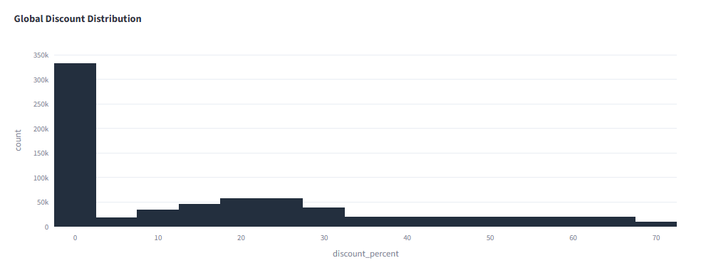
Module 5: Operations & Logistics Overview
The primary objective of this module is to minimize operational costs while maximizing delivery speed and accuracy. It bridges the gap between inventory management and customer satisfaction. It tracks how a product moves from a supplier, through a warehouse, and finally to the customer’s doorstep.
1. Fulfillment & Warehouse Efficiency
This section focuses on the "internal" logistics—what happens once an order is placed but before it leaves the building.
- Process Tracking: Measuring the time taken to "Pick, Pack, and Ship."
- Capacity Management: Using the schedule data to ensure the warehouse isn't over-capacity, which leads to bottlenecks.
- Objective: Reduce the Order Cycle Time to ensure rapid hand-off to delivery partners.
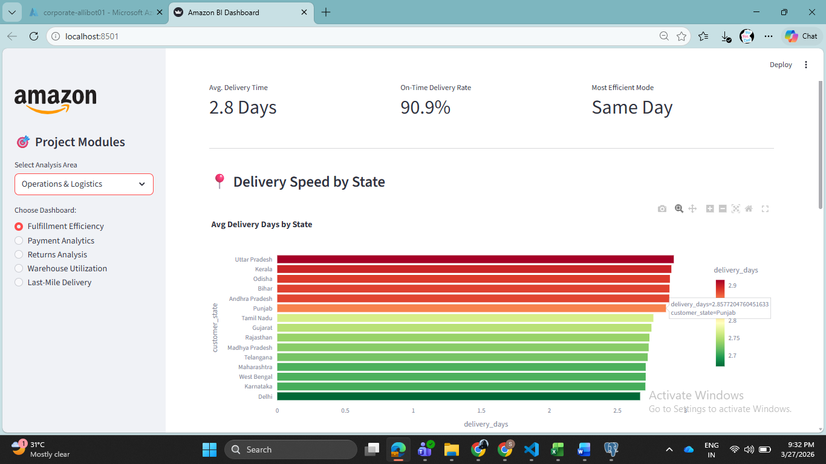
2. Payment Analytics
Logistics isn't just about boxes; it's about the flow of money.
- Transaction Integrity: Monitoring success rates across different gateways (e.g., Stripe, PayPal, UPI).
- Cost Analysis: Identifying which payment methods have high transaction fees that eat into profit margins.
- Risk Mitigation: Tracking "Payment Trends" to spot sudden spikes in failed transactions which might indicate a technical outage.
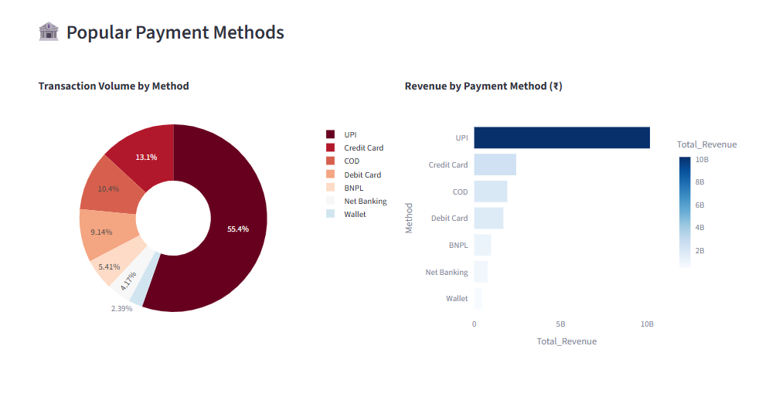
3. Return & Cancellation Management
Commonly known as Reverse Logistics, this is often the most expensive part of operations.
- The "Why" Analysis: Categorizing returns (e.g., "Damaged in Transit" vs. "Wrong Item Shipped").
- Quality Feedback Loop: If a specific category has a 15% return rate, this data is pushed back to the Supply Chain team to re-evaluate that vendor.
- Sustainability: Reducing returns directly reduces the carbon footprint and packaging waste of the project.
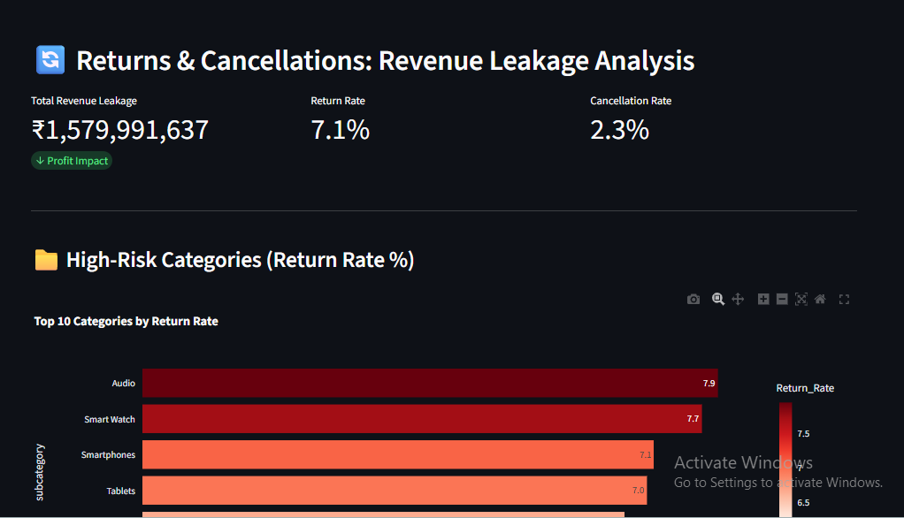
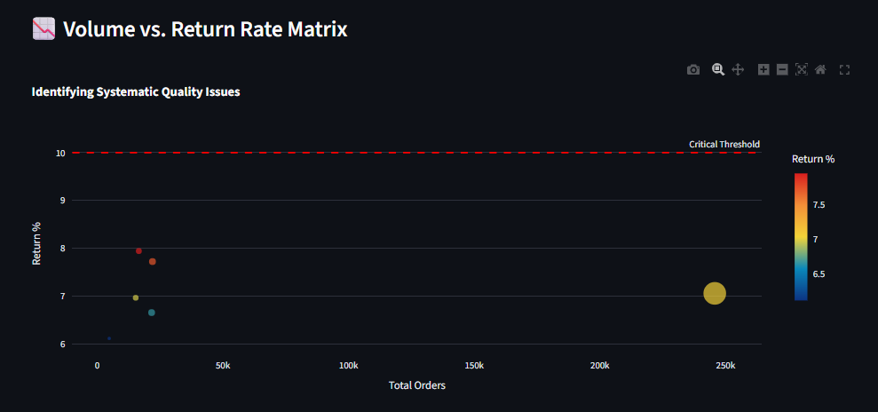
4. Customer Service & Satisfaction (CSAT) Dashboard
- Objective: Measures the quality of customer experience by correlating delivery speed with direct user feedback and sentiment.
- Key Metrics: Tracks Average CSAT Score (1–5 stars), Promoter % (NPS Proxy), and Average Resolution Time (Days to Deliver).
- Sentiment Analysis: Automatically segments users into Promoters, Passives, or Detractors based on their numeric ratings to identify at-risk customers.
- Root Cause Mapping: Uses a Top 10 Complaint Volume bar chart to pinpoint which product subcategories drive the most returns and dissatisfaction.
- Predictive Insight: Features a Speed vs. Satisfaction scatter plot with an OLS trendline to prove how faster logistics directly improve brand loyalty.
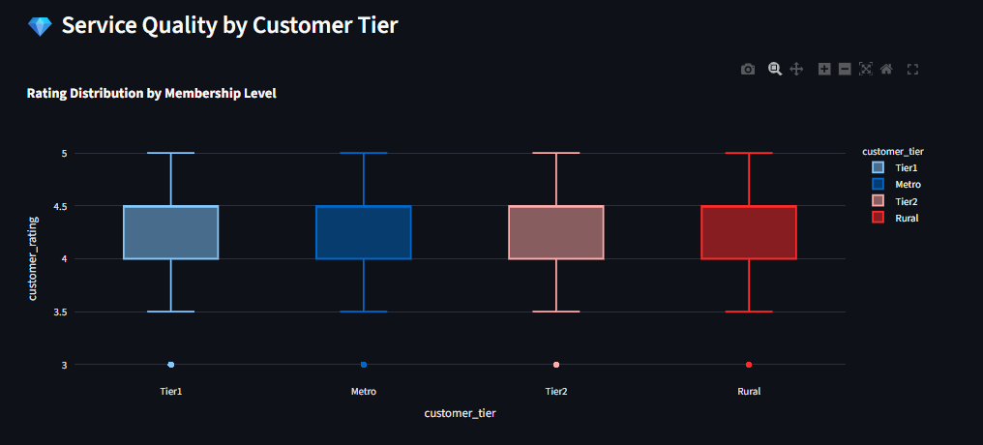
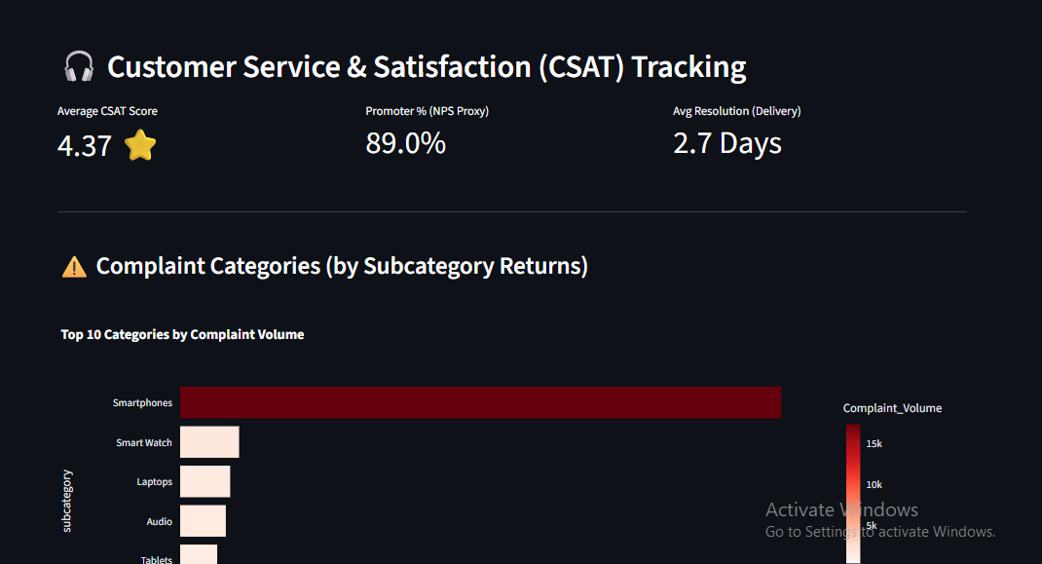
- Last-Mile Delivery Performance
The "Last Mile" is the final leg of the journey and usually the most expensive and complex.
- OTD (On-Time Delivery): The gold standard metric. If OTD drops below 95%, the dashboard triggers an alert for specific geographic regions.
- Geographic Variation: Analyzing if certain cities or zip codes have higher delay rates due to local courier inefficiency or infrastructure issues.
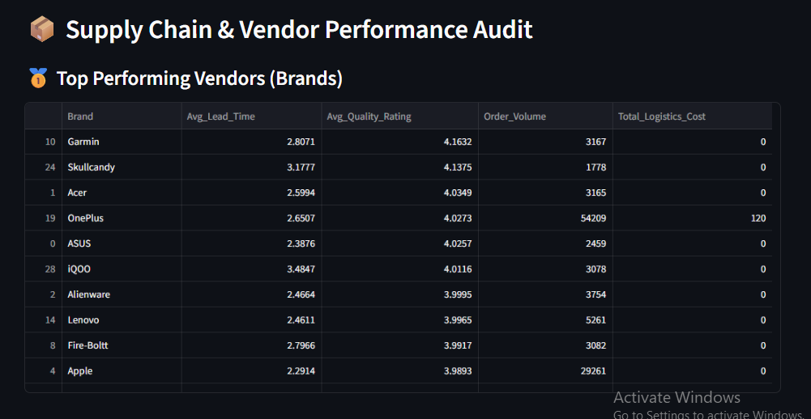
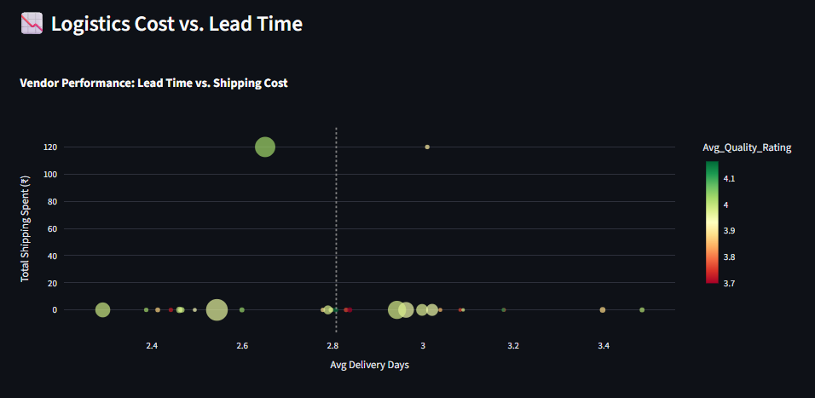
Module 6 : Advanced Analytics Module Overview
This module leverages machine learning and statistical modeling to provide a competitive edge. It focuses on foresight rather than hindsight.
1. Predictive Sales & Forecasting
Objective: To project future revenue and volume to ensure the business is prepared for growth or market dips.
- Methodology: Uses Time-Series Analysis (ARIMA or Prophet models) to identify patterns in historical data.
- Key Metrics: * Forecast Accuracy: The variance between predicted vs. actual sales.
  - Growth Trajectory: Projected Year-over-Year (YoY) growth.
- Use Case: Helping the finance team set realistic quarterly targets based on the data trends.
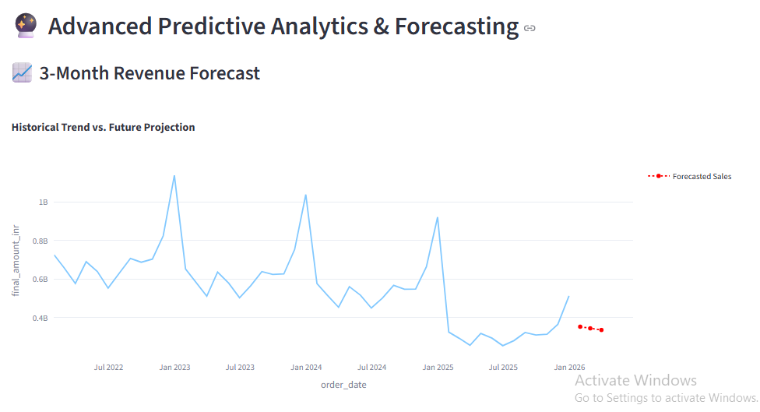
2. Customer Churn Prediction
Objective: To identify "at-risk" customers before they stop using the service.
- Logic: Analyzes behavioral triggers like decreased login frequency, support tickets, or missed payments.
- Key Metrics: * Churn Probability Score: A 0–100% risk rating for every active user.
  - LTV (Lifetime Value): The total projected revenue from a customer over their entire relationship with the brand.
- Visual Strategy: A Risk Matrix highlighting high-value customers who are likely to leave soon.
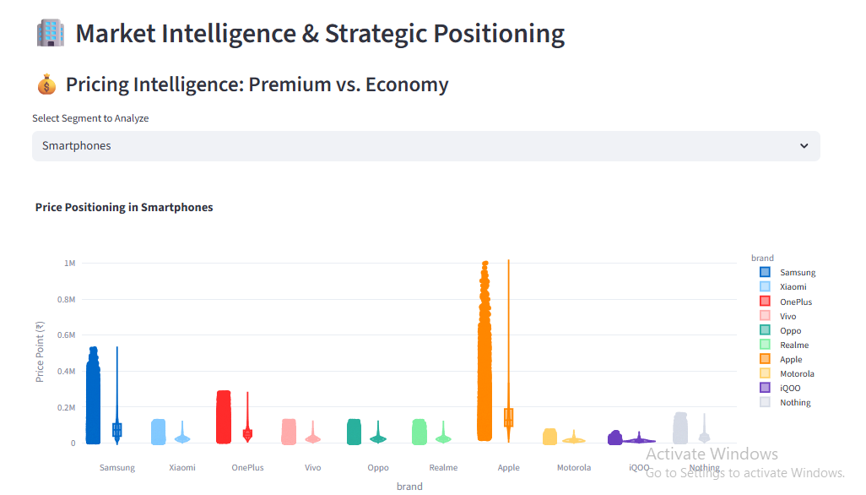

3. Product Recommendation (Cross-selling & Upselling)
Objective: To increase the Average Order Value (AOV) by suggesting relevant items.
- Logic: Uses Market Basket Analysis (Association Rules) to find products often bought together (e.g., if a user buys a Camera, suggest a Tripod).
- Key Metrics: * Attach Rate: The percentage of orders containing more than one recommended item.
  - Upsell Conversion Rate: Success rate of moving a customer from a "Basic" to a "Premium" product.
- Visual Strategy: Network Diagrams showing the strongest associations between product categories.
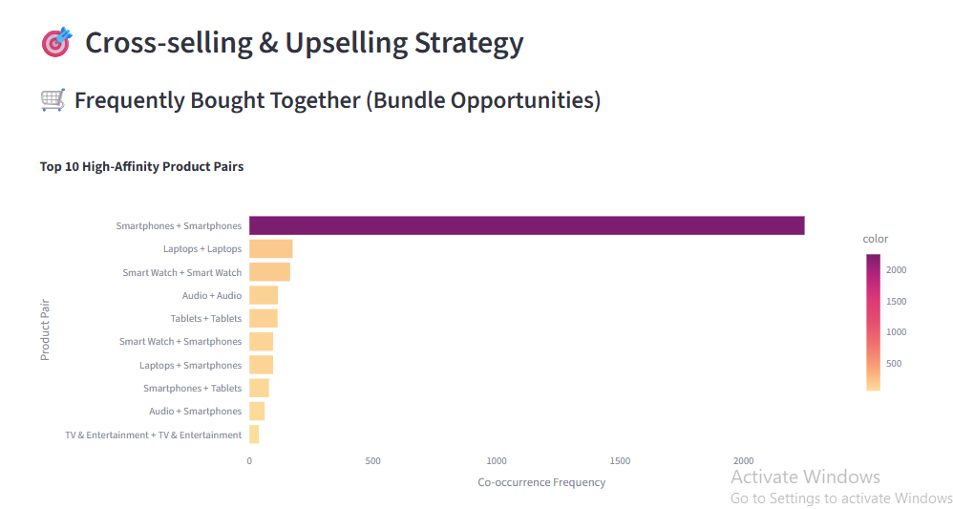
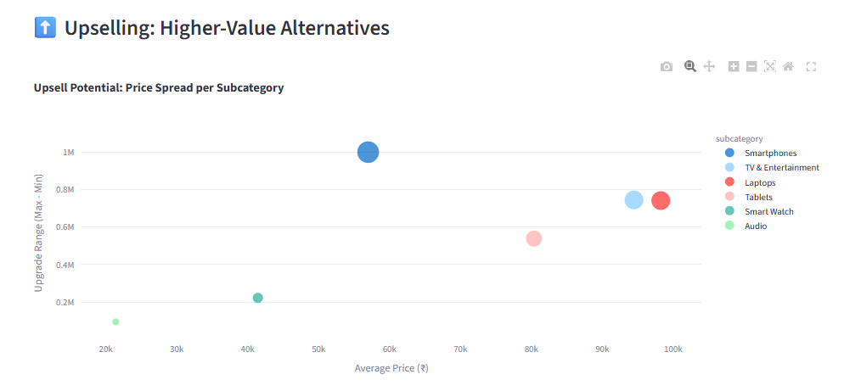
4. Sentiment Analysis
Objective: To quantify the "mood" of the customer base across social media, reviews, and support tickets.
- Logic: Uses Natural Language Processing (NLP) to categorize text as Positive, Neutral, or Negative.
- Key Metrics: * Net Sentiment Score: The balance of positive vs. negative feedback.
  - Top Complaint Themes: Automated clustering of common issues (e.g., "Late Delivery," "App Crash").
- Value Add: Provides early warnings for PR crises or product defects before they impact the bottom line.
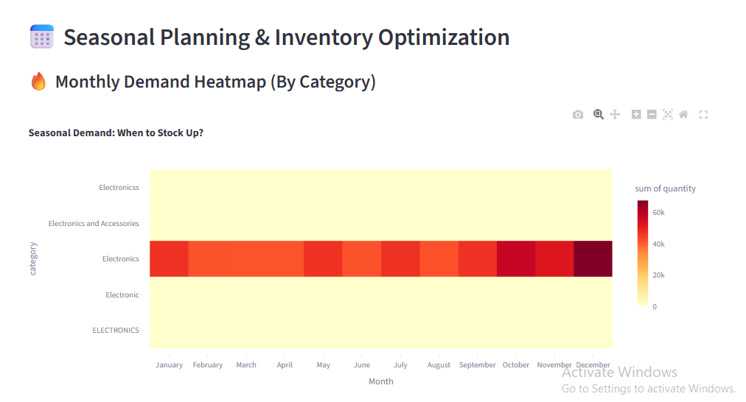
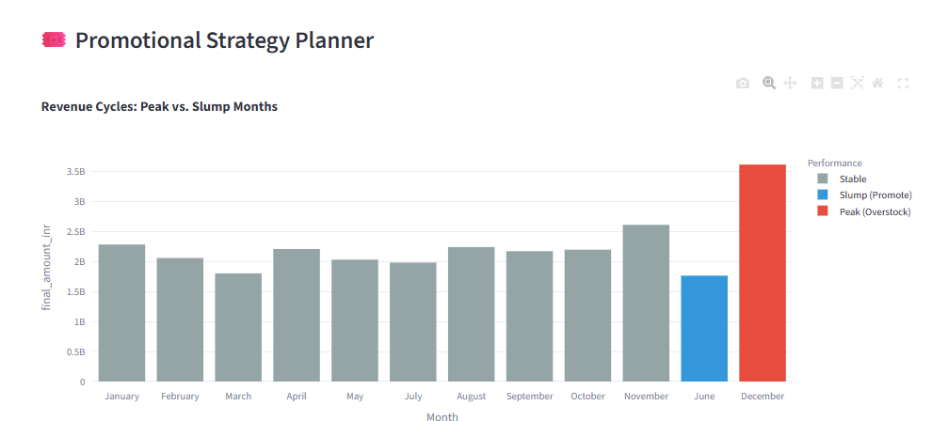
5. Supply Chain Optimization
Objective: To balance the cost of holding inventory against the risk of stockouts during peak seasons.
- Logic: Combines seasonal trends with real-time logistics data to suggest optimal reorder points.
- Key Metrics: * Safety Stock Levels: The "buffer" inventory needed to prevent stockouts.
  - Economic Order Quantity (EOQ): The ideal order size to minimize both ordering and carrying costs.
- Decision Support: Automated alerts when current inventory levels won't meet the predicted 30-day demand.
